WEEK 5 – SPL 5
Pure metals – ductile and soft
This softness arises because of their low lattice resistance — that is, there are few obstacles in the crystal structure to resist dislocation motion (which leads to plastic deformation).
Therefore, to make the ‘stronger’ we use:
Method | Mechanism | Process | Microstructure Effect | Typical Application
Solid Solution Strengthening | Solute atoms distort the crystal lattice, hindering dislocation motion | Add alloying elements; atoms dissolve into solid solution (e.g., Zn in Cu) | Uniform solid solution, lattice strain due to atom size mismatch | Brass (Cu-Zn), Stainless steel (Cr in Fe)
Precipitation Hardening | Fine precipitates form and obstruct dislocations | Heat treat to form solid solution, quench, then age to form precipitates | Precipitates dispersed in the matrix (e.g., CuAl₂ in Duralumin) | Al-Cu (Duralumin), Ni-based superalloys
Work Hardening | Plastic deformation increases dislocation density, which entangles | Cold working (e.g., rolling, drawing, hammering) | High dislocation density and strain-hardened regions | Cold-rolled steel, metal forming processes

Solid solution – substitutional (big) and interstitial (small)
METAL TYPES
FERROURS ALLOYS – IRON IS THE PRIME CONSTITUENT- low carbon steel, high carbon steel, stainless steel, cast iron, grey iron and white iron.
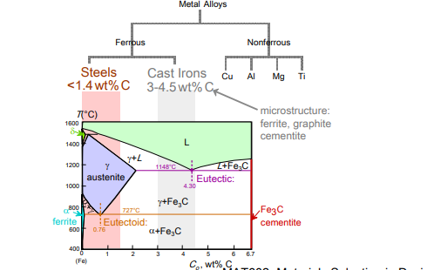
NON- FERROUS ALLOYS – copper alloys, aluminium alloys, titanium alloys and magnesium alloys.

TAXONOMY OF METALS
Anything below 1.4% carbon = steels- can plastically deform
Anything above = cast iron

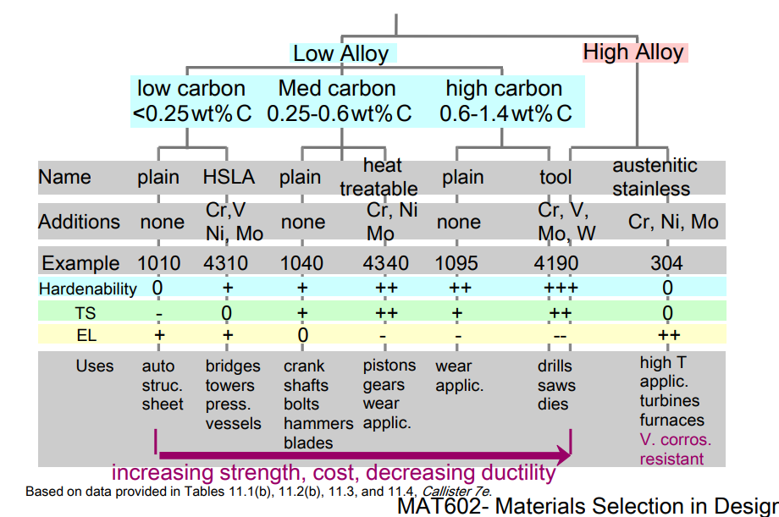

Types of cast iron
1. Gray Cast Iron
- Graphite in flakes (sharp, irregular shapes)
- Flakes act as stress concentrators → weak under tension
- But it's stronger under compression and offers:
  - Excellent vibration damping (used in machinery bases)
  - Good wear resistance
- Matrix = ferrite (softer) or pearlite (stronger)

2. Ductile (Nodular) Iron
- Made by adding Mg or Ce → changes graphite to nodules (spheres)
- Spheroidal graphite means less stress concentration → much better ductility and toughness
- Matrix is often pearlitic for strength

3. White Cast Iron
- No graphite; carbon is mostly iron carbide (Fe₃C or cementite)
- Very hard and wear-resistant, but very brittle
- Formed via fast cooling, doesn't allow graphite to form
4. Malleable Cast Iron
- Made by heat treating white iron at 800–900°C for 30+ hours
- This transforms iron carbide into graphite "rosettes"
- Offers good ductility with moderate strength
NON- FERROUS
Nonferrous alloys are metallic alloys that do not contain iron (Fe) as a major component. These materials are often valued for:
- Lightweight
- Corrosion resistance
- High strength-to-weight ratio
- Specialized thermal or electrical properties
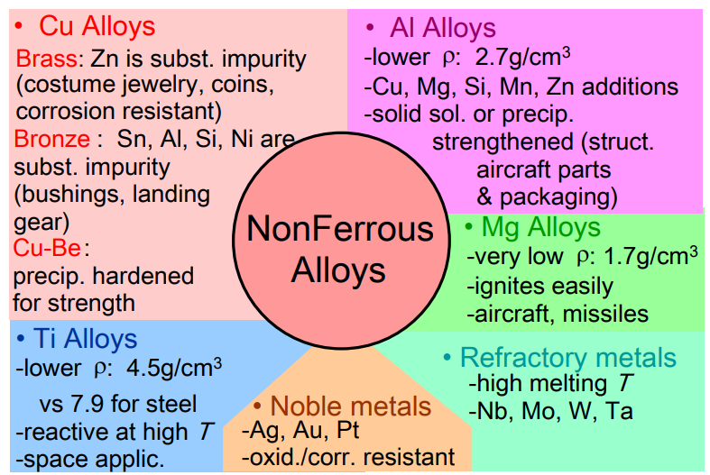
Cost depends on melting as all materials need to be melted to be processed
DESIGN CONSIDERATION
Design Challenge | Explanation
Cooling Shrinkage | Metals contract when cooled from melt, which affects dimensional accuracy.
Air Gap Formation | Shrinkage during cooling creates a gap between metal and mould, reducing heat transfer.
Work Hardening | Plastic deformation increases strength, limiting further shaping unless annealed.
Limited Plastic-Forming | Excessive deformation risks cracking; shaping must be done in steps.
Corners Difficult to Form | Metals struggle to fill sharp mould corners, leading to defects.
Unidirectional Pressing | Forging presses push in one direction; liquids can fill complex moulds better.
Phase Changes | Structural changes on heating/cooling influence mechanical properties and process control.

INGOT CASTING- usually reheated/reshaped into useful products – is the first stage
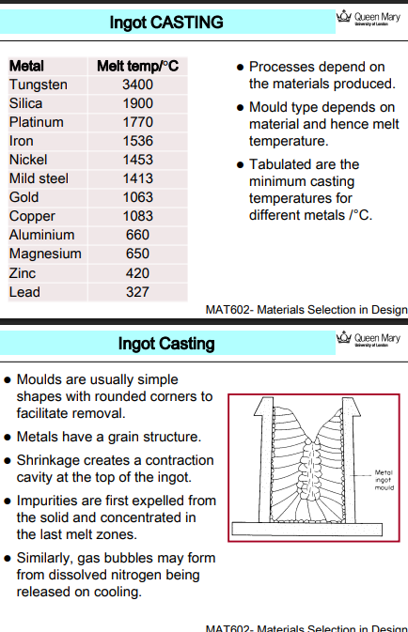
- Ingot casting involves pouring molten metal into molds to form simple, solid shapes called ingots.
- The melting temperature of a material determines the casting process and mold design.
- Metals must be heated above this temperature to be cast, and mold materials must withstand it without degrading.


Q: What are typical mold characteristics for ingot casting?
A: Molds are generally simple in shape with rounded corners. This design eases removal of the solidified ingot and minimizes stress concentrations that might lead to cracks during cooling.
Q: What is meant by the grain structure in metals?
A: After solidification, metals develop a crystalline grain structure. The nature of this structure affects mechanical properties like strength and toughness.
Q: What causes the contraction cavity at the top of the ingot?
A: As molten metal cools, it shrinks. Since solidification starts at the mold walls and proceeds inward and upward, a cavity often forms at the top, where the last part remains molten and contracts as it solidifies.
Q: What happens to impurities during solidification?
A: Impurities are usually expelled from the solidifying front and concentrated in the last melt zones, which often end up at the top of the ingot.
Q: How do gas bubbles form during ingot casting?
A: Gases (like nitrogen) that were dissolved in the molten metal can come out of solution upon cooling, forming gas bubbles or porosity in the ingot.

PROBLEMS WITH INGOT CASTING
- Contraction cavities
  - Ingot casting creates a shrinkage hole at the top because metal shrinks when it cools.
- Segregation of impurities
  - Impurities (and alloying elements) are pushed to the last melt zones, usually the center or top, creating non-uniform composition.
- Gas porosity
  - Gases like nitrogen can get trapped and form bubbles or voids.
- Larger starting size
  - Ingots are large, so more energy and effort is needed to shape them later (e.g., into sheets or rods).
Therefore, CONTINUOUS CASTING
- No shrinkage cavity
- Less segregation:
- The columnar grains (crystals) form over shorter distances, so impurities don't have time to separate much — leading to more uniform material.
- Smaller product = less work later:
- The output is already in slab or rod shape, so less rolling or forging is needed later to get it into usable form.
PERMANENT PATTERN (SAND CASTING)
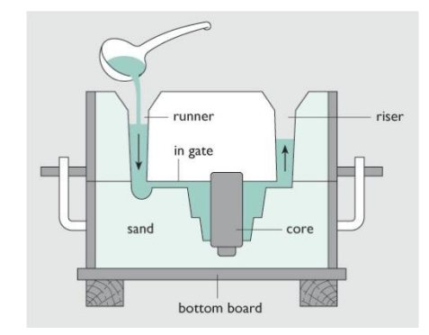
Sand casting is a method where molten metal is poured into a mold made of sand. Once the metal cools and solidifies, the sand mold is broken to remove the final part.
- A pattern is made (usually wood, metal, or plastic).
- It is pressed into sand to make a mold cavity.
- The pattern is removed, leaving behind the shape.
- A core may be added for internal features.
- Molten metal is poured into the mold via the gate.
- Once it cools and solidifies, the sand is broken apart, and the casting is removed.
- The mold is discarded, but the pattern is reused to make more castings.
Why use this method?
- Low cost for small production runs
- Flexible shapes (including complex geometries)
- Large parts can be made easily
- Reusable pattern makes it cost-effective over many castings
Automated sandcasting
Automated sand casting uses machines to rapidly and repeatedly form sand molds, enabling high-volume production of cast parts. This method dramatically increases casting speed compared to traditional hand-packed molds.

DIE CASTING / PERMANENT MOULDS
Die casting involves injecting molten metal under pressure into a reusable metal mould (die) to produce accurately shaped parts. Unlike sand casting, the mould is not destroyed after each use — it’s opened and reused for thousands of cycles.
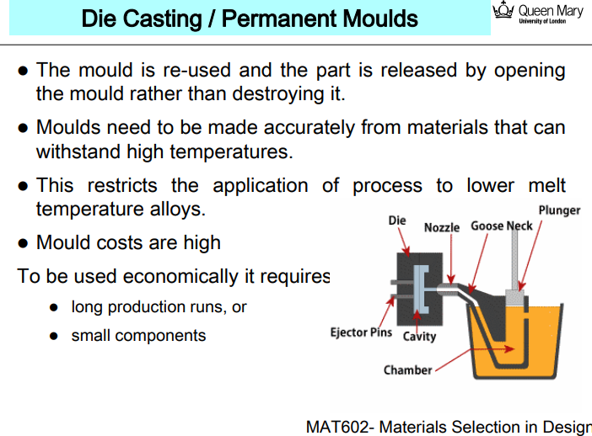
High-temperature materials needed for the die:
- Since molten metal is hot, the die must be made of materials like hardened tool steel that can withstand repeated heating.
Limits the process to lower melting point metals:
- Dies cannot handle extremely high temperatures (like for steel), so this process is mostly used with aluminium, zinc, magnesium, etc.
High cost of moulds (dies):
- Dies are expensive to manufacture due to the complex design, precision machining, and materials.
- This is why die casting is economical only when:
  - Producing large quantities (to spread the mould cost),
  - Making small components (less metal = less heat = longer die life).
Expendable Mould (Investment Casting)
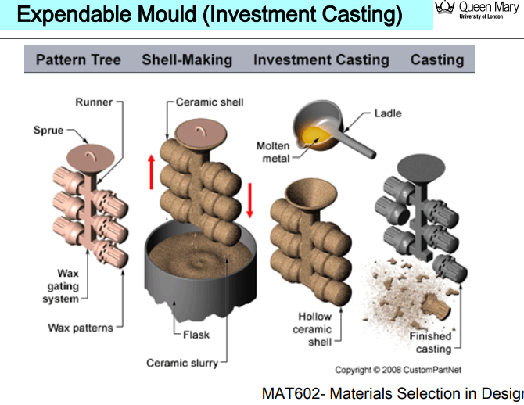
- Making a wax model of the part
- Coating it in ceramic to form a mould
- Melting away the wax (hence “lost wax”)
- Pouring molten metal into the hollow ceramic shell
- Breaking the shell to reveal the final part

FORMING – METAL FABRICATION METHODS
Process | Force Type | Product Type | Notes
Forging | Compressive | Tools, shafts | High strength; hot or cold
Drawing | Tensile | Wires, tubes | Requires clean, lubricated dies
Rolling | Compressive | Sheets, rails, beams | Hot = easy forming, Cold = better finish
Extrusion | Compressive/Ram | Long rods, hollow tubes | Ductile metals, continuous profile

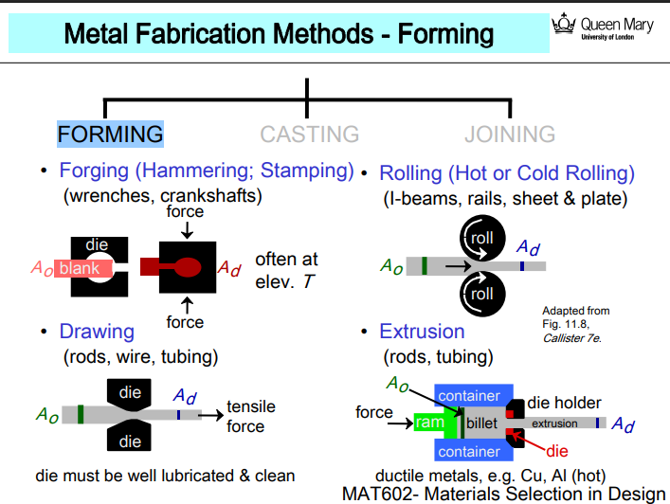
FORGING Method: A metal blank is placed between dies and hit with a hammer or press.
DRAWING Method: A metal rod is pulled through a die, reducing its cross-sectional area.
ROLLING Method: A metal piece is passed between two rotating rolls.
EXTRUSION Method:
- A metal billet is placed in a chamber.
- A ram pushes it through a die.
- The metal flows out as a continuous profile.
METAL FORMING
We use metal forming because casting has defects – cant fill voids/ cavity and holes therefore cost can be reduced
Long shapes harder to cast
Best casting from EUTECTIC ALLOYS but not always desirable
INHOMOGENITY- common in casting but plastic deformation reduces this. Casting often causes uneven structure due to cooling. Forming evens it out through plastic deformation.
Some materials difficult to process as liquid due to high MELT temp – REFRACTORY MATERIALS - better shaped through forming or powder processes.
CLASSIFICATIONS OF FORMING PROCESSES
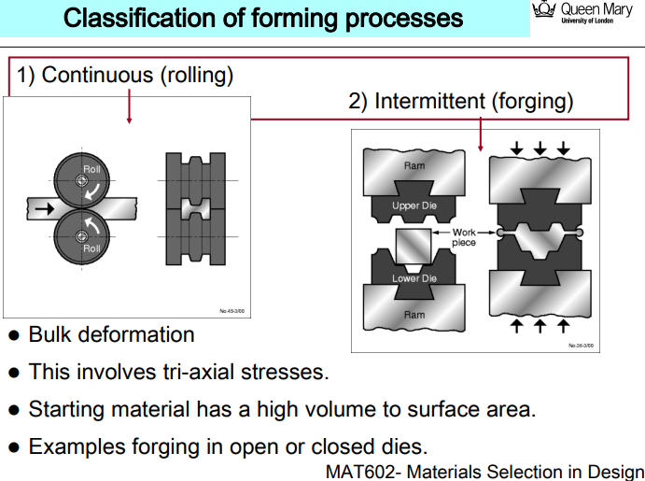
FORGING
Hot Forging
- Benefits:
  - Allows large deformations (big changes in shape)
  - Easier to shape metals due to reduced strength at high temperatures
- Drawbacks:
  - Poorer surface quality
  - Lower dimensional accuracy
  - Problems like oxidation (metal reacting with air) and warpage (distortion when cooling)
Cold Forging
- Benefits:
  - Produces more precise parts
  - Results in a better surface finish
- Drawbacks:
  - Requires higher pressures to deform metal (since it's not softened by heat)
  - Limited deformation due to work hardening (material becomes stronger and harder as it's shaped)
- Formability and Bend Radius
- Formability is how easily a sheet can be bent or stretched without cracking.
- It's often measured as the minimum bend radius in multiples of sheet thickness (t):
  - t = 1 → excellent (can bend sharply)
  - t = 4 → average (needs wider bend)
2. Radii Design Rule
- Bending edges and corners should have large radii.
- Ideally, radius ≥ sheet thickness to prevent cracking during bending.
3. Stretching & Drawing Limits
- Formability also affects how far a sheet can be stretched or deep drawn (e.g. into a cup shape).
- Poor formability leads to necking (local thinning) and failure.
4. Forming Limit Diagrams (FLDs)
- FLDs provide a quantitative guide to forming safety.
- They plot strain combinations (major vs. minor strain) that a sheet can survive before failing.
- Used in advanced simulations and product design to predict failure points.
5. Design Strategy
- Engineers design components to ensure strain levels stay below the forming limit, as shown in FLDs.
- This prevents tearing, cracks, or part rejection during manufacturing.
Feature | Hot Rolling | Cold Rolling
Temperature | High (T > 0.35 Tₘ) | Low (T < 0.35 Tₘ)
Pressure | Low | High
Surface Finish | Rough | Smooth
Strength | Low | Higher (due to work hardening)
Accuracy | Less | More
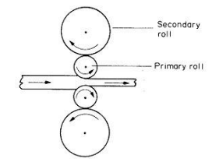
Rolling

Well designed rolling mills have rolls of small diameter (primary roller) these can be supported by additional secondary roles which do not touch the work piece!!
FORGING OF A GEAR CHECK HAND NOTES
METAL CONSIDERATIONS

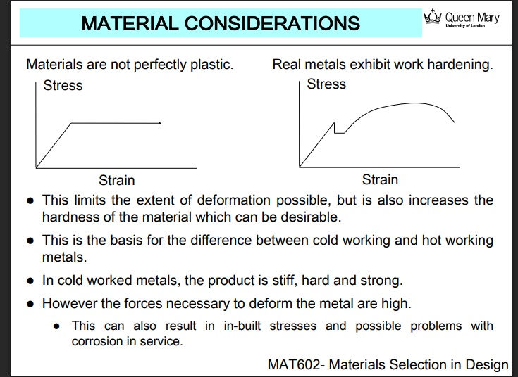
📉 Left: Idealized (Perfectly Plastic) Material
📈 Right: Real Metal Behavior (with Work Hardening)
- Stress increases again after yielding due to work hardening.
- As the metal is deformed, it becomes stronger and harder, resisting further deformation.
Real metals are not perfectly plastic
- They exhibit work hardening (also called strain hardening), which limits how much they can be deformed.
Work hardening increases hardness
- This can be useful for strength, but also makes further shaping harder.
Cold working vs. Hot working
- This difference in behavior underpins the contrast:
  - Cold working happens below recrystallization → strong but difficult to deform
  - Hot working allows easier shaping with less hardening
Cold worked metal = Stiff, hard, strong AND Higher forces are needed to deform hardened metal

SHEET DEFORMATION
Process | Description | Key Stress State | Notes
Blanking | Cutting sheet using punch & die | Shear | Removes a shape from the sheet
Deep Drawing | Forming sheet into a cup or can | Biaxial/Triaxial | Involves bending and stretching
Limitation | Side walls may fracture | Tensile stress | Walls thicken; overstretching causes failure

Deep Drawing:
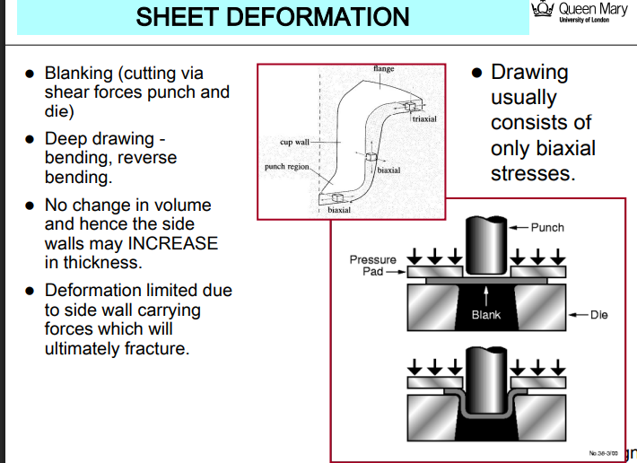
- No volume change:
The material doesn't lose volume, so side walls may thicken as the material is drawn inward.
- Stress conditions:
  - Most of the process involves biaxial stresses (stretching in two directions).
  - Some regions (like the flange) experience triaxial stress (important in fracture behavior).
- Deformation Limits:
  - Limited by the ability of the side walls to carry the tensile loads.
  - Eventually, if overstretched, the walls fracture or tear.
HOT WORKING
Hot worked metals can exhibit 2 features:
- REDUCED YIELD STRESS
- RECOVERY AND RECRYSTALLISATION
MACHINING
Machining refers to processes where material is removed (cut, ground, or milled) from a workpiece to shape it with high precision. Examples include:
- Turning, milling, drilling, grinding, and CNC machining
Often a secondary operation to ‘finish’ parts produced by e.g., casting.
Sometimes it is PRIMARY process:
- Low-volume production
- Prototyping
Doesn’t need dedicated tooling for each part — generic machines like CNC mills or lathes can handle various designs.
Tooling costs = LOW!

CUTTING PROCESSES
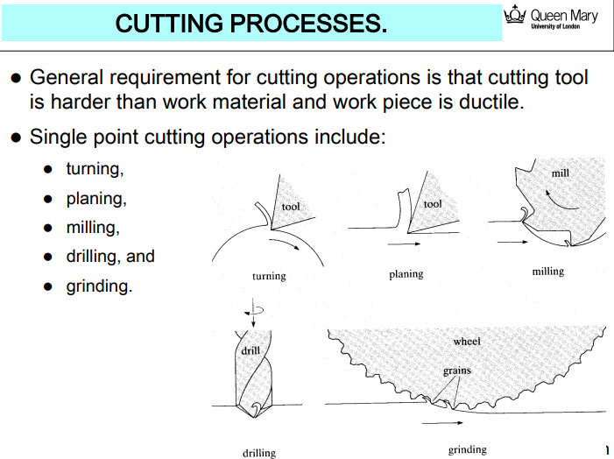
JOINING – METAL FABRICATION METHODS
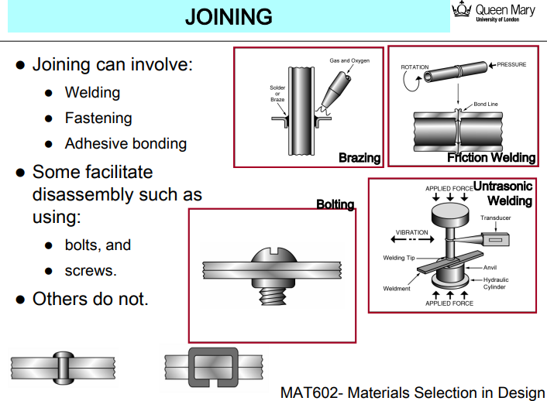

🔥 Brazing
- Uses heat and a filler metal (like solder) to join parts without melting the base metal.
- Gas torch shown adding filler between closely fit metal pieces.
- Moderate strength, commonly used in pipes and electronics.

🔄 Friction Welding
- Parts are rotated and pressed together.
- Friction heats the interface, and pressure bonds them without melting.
- Often used in automotive/aerospace shafts.

🔊 Ultrasonic Welding
- A vibrating tool (sonotrode) applies high-frequency mechanical vibrations with pressure.
- Used for plastics or light metals (e.g., copper wires, lithium-ion batteries).
- Fast, clean, and no filler needed.

🔩 Bolting
- Mechanical fastener (bolt + nut or threaded hole).
- Easy to assemble/disassemble.
- Common in construction, automotive, machinery.

